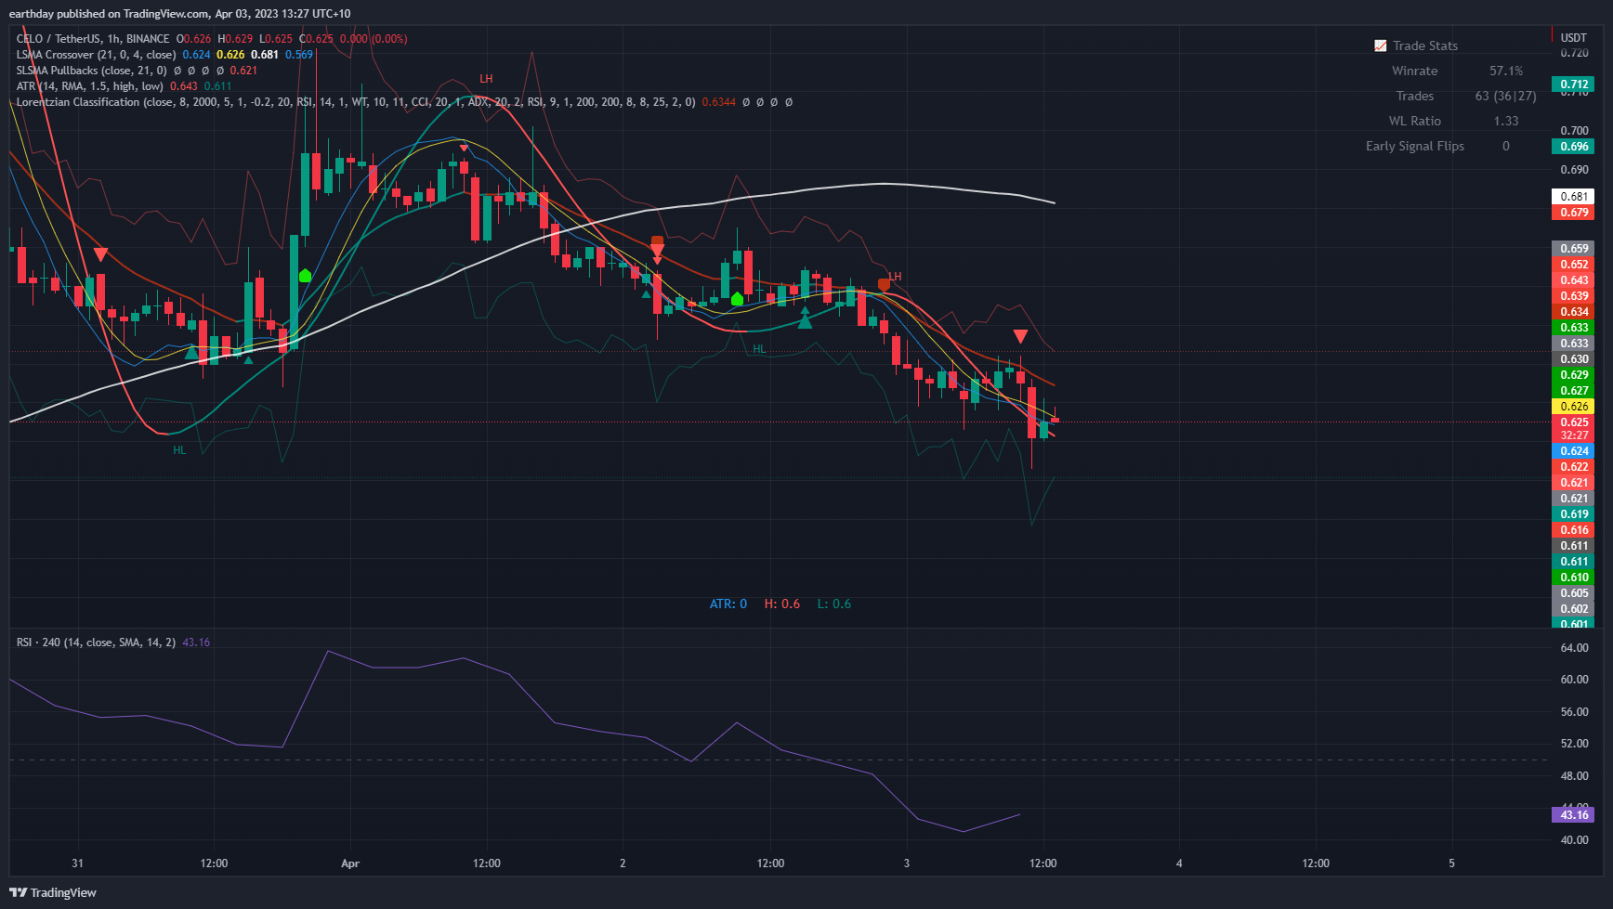

Indicators:

LSMA Crossover (by Veryfid)

SLSMA Pullbacks (by Veryfid)

Lorentzian Classification (type Machine Learning into ‘Indicators’ in TradingView, by jdhorty)

ATR Stop Loss Finder (by Veryfid)

RSI (by TradingView)

**Other criteria – be able to:**

***Set Risk/Reward***

***Enter Short Only/Long Only***

***Option of Selecting Exit Type***

1. ATR
2. Price touches the regression line (referred to as a Kernel) within the Lorentzian Classification Indicator
3. LSMA crossover

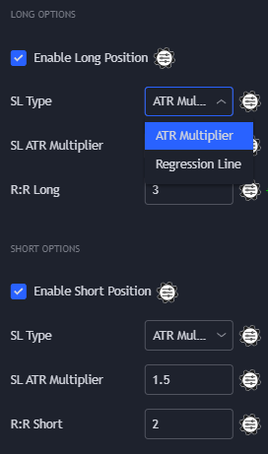

1. Change of colour in Lorentzian regression line (Kernel) or SLSMA regression line (See image below)
2. An opposite signal (long/short) is generated for either the Lorentzian Classification, or SLSMA Pullbacks indicators (See image below)

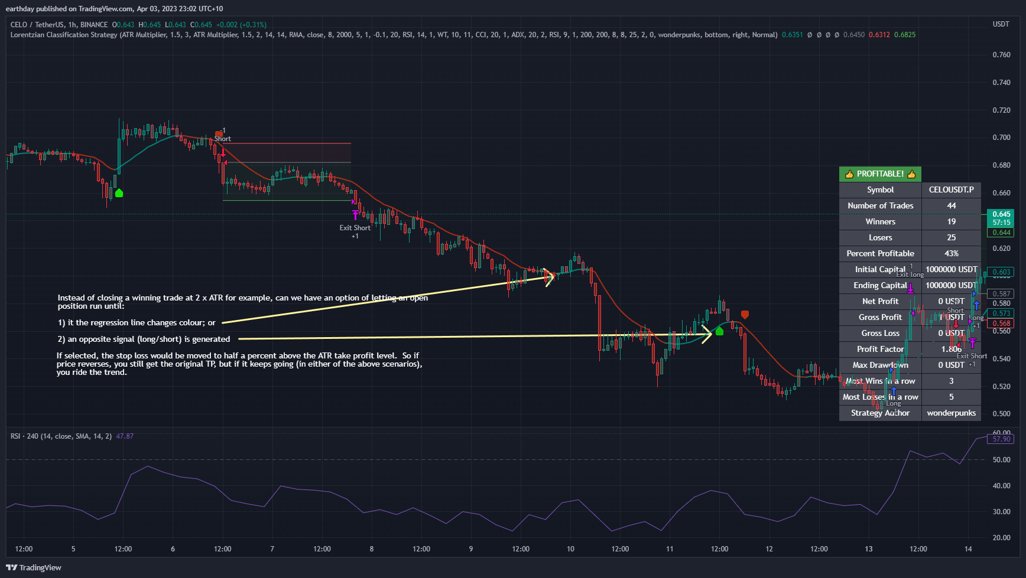

***Entry***

1. RSI above/below 50, signal from Lorentzian Classification or SLSMA Pullbacks [DONE]
2. RSI above/below 50, price above/below ‘Long’ (white line) moving average in LSMA Crossover, signal from Lorentzian Classification or SLSMA Pullbacks (see below screencaps)

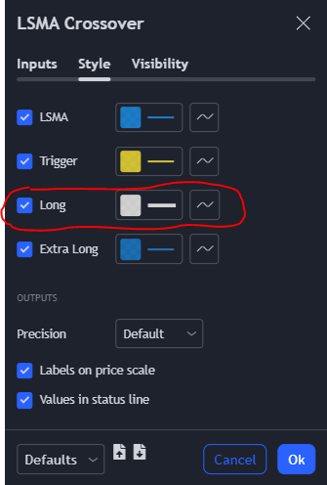

Long Entry Example

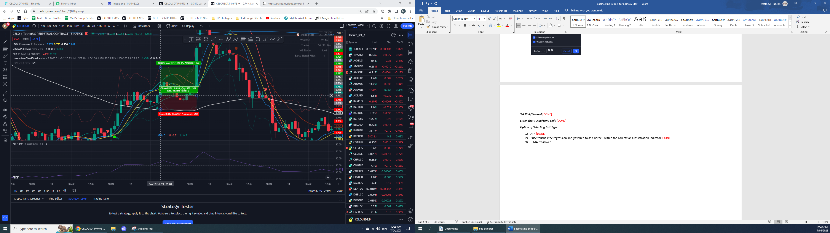

***Set a maximum SL or minimum TP %***

Set a maximum SL or minimum TP % – so if I only wanted to risk 4% in a trade, ~~it wouldn’t take a trade if the ATR showed a stop loss of 8%~~

Sometimes the ATR SL is too high (8% for example). It would be good to be able to set the max I’m prepared to lose (3.5% for example). The TP would then be adjusted to align with the max SL. So if my max loss is 3.5%, but ATR is 8%, a 2x RR would adjust to 7% (2 x 3.5%), instead of 16% (2 x 8%).

[[I had mentioned initially that it wouldn’t take the trade if the ATR was too high. Instead of this, I would prefer that the ATR is overridden by the Max SL, if the max SL is 3.5%, but ATR is 8%, it will still take the trade, but the TP will be 7% (not 16%).]]

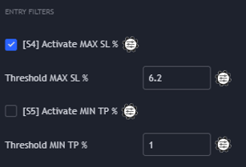

***RSI Option for Selecting a Timeframe***

Have the following parameters for RSI. I use a 4 hour RSI timeframe on a 1 hour chart. Can you also add LSMA as an MA type in the ‘MA Type’ field.

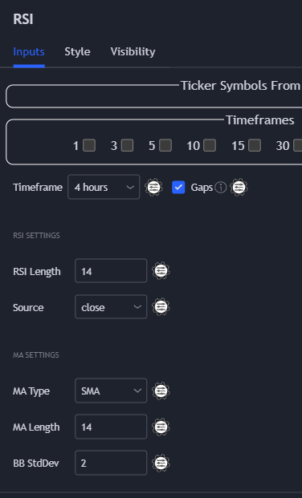

***Miscellaneous***

Be able to run backtests, and adjust parameters to see the impact on the backtested results (e.g. winrate, P&L, drawdown etc)

SLSMA Pullbacks has smaller arrows and larger arrows – I’m only trading the larger arrows.